|  |  |  |  |
| --- | --- | --- | --- |
| 1 | | 24,744.0 | |
| NUMERO DE FRONTERAS | | ENERGIA AGREGADA | |
|  | | | |
|  | |  | |
| CONTRATO | | VENCIMIENTO CONTRATO | |
|  | | | |
| 10,806,295 | 20 | | 494,880 |
| INGRESO 2020 | DÍAS CERTIFICADOS 2020 | | ENERGIA RESPALDADA 2020 |
|  | | | |
| 39,976,167 | 69 | | 1,707,312 |
| INGRESO 2021 | DÍAS CERTIFICADOS 2021 | | ENERGIA RESPALDADA 2021 |

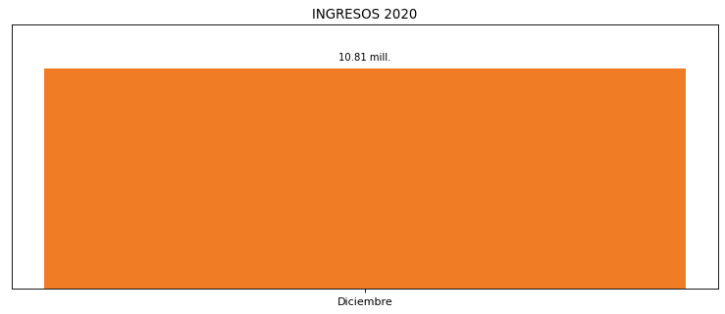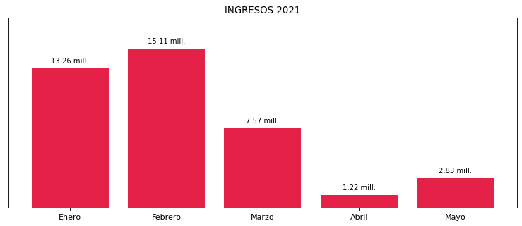

|  |
| --- |
| **COCA COLA BOGOTA**  USUARIO |

|  |
| --- |
| **Mateo Porras**  Ejecutivo de cuenta |

|  |
| --- |
| Primera fecha: PUNTO FOCAL |

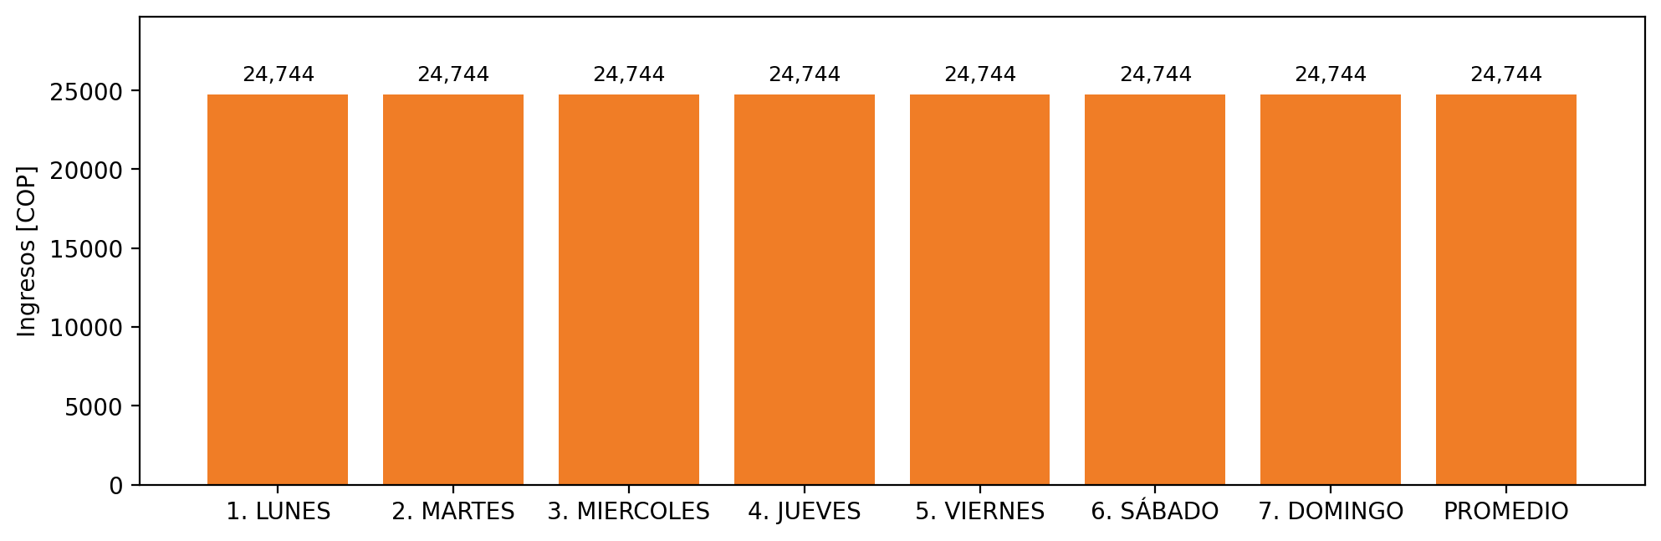

|  |  |  |  |  |  |  |  |  |  |
| --- | --- | --- | --- | --- | --- | --- | --- | --- | --- |
| **FRONTERA COMERCIAL** | **TIPO DDV** | **COD SIC** | **PREDIO** | **PROMEDIO** | **MARGEN** | **ÚLTIMA DESCONEXION** | **DÍAS CERTIFICADOS** | **ACTUALIZACION** | **PROXIMA PRUEBA DDV** |
| INDUSTRIAL DE GASEOSAS S.A. - INDEGA S.A. | Frt38600 | Frt00670 | Prd02087 | 24,744 | NO APLICA | 2020-11-24 | 89.0 | 2023-04-15 | 2021-11-29 |